Bonding and physical properties
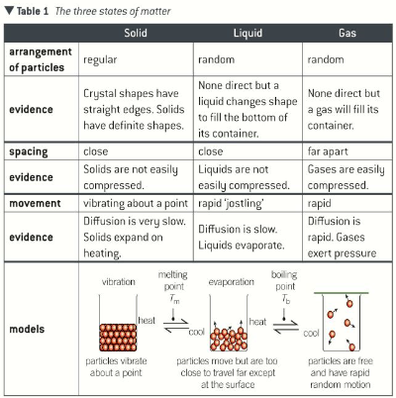
turning a solid to liquid (fusion)
- When heating, a solid or supplying energy, it vibrates to a more fixed position therefore increasing the distance between particles so it expands
- Supplying more energy can turn a solid into a liquid – this is required to weaken the forces that act between the particles
- Energy known as the enthalpy change of melting
- When a solid is melting, the temperature does not change as the heat is absorbed as the forces are weakened
Enthalpy = the heat energy change measured under constant pressure
Temperature depends on the average kinetic energy which is also related to their speed
Turning a liquid to a gas (vaporisation)
- Particles move further apart after being supplied energy therefore liquids also expand when heated
- Energy is required to break all the intermolecular forces between the particles
- Energy known as enthalpy change of vaporisation
- No temperature change during the process of boiling
- Gases expand a great deal when heated because they also gain kinetic energy and move further apart
Crystals
- Have a regular arrangement and are held together by forces of attraction
- The strength of forces of attraction has an effect on the physical properties of crystals
- Stronger the force, the higher the melting point/temperature and a greater the enthalpy
Molecular crystals – consist of molecules held in a regular structure by intermolecular forces and molecules held together by covalent bonds however are much weaker so have a low melting temperature and low enthalpy
Properties
- Crystals are soft and break easily
- Low melting point temperature
- Does not conduct electricity because there are no charged particles
Diamond (macromolecular crystal)
- Polymorph or allotrope of carbon
- Consists of pure carbon with covalent bonding between every carbon atom
- Giant structure – bond spreads throughout the structure
- Each carbon forms four single covalent bonds with other carbon atoms
- These four electrons repel from each other – electron pair repulsion theory
- Bond angles of 109.5°

Properties of diamond
- Very hard material
- Very high melting temperature (over 3,700k)
- Does not conduct electricity because there are no delocalised electrons to carry the charge
Graphite
- Consists of pure carbon atoms which are bonded and arranged differently
- Strong covalent and weak van der Waals forces
- Bond at angle 120°
- Leaves each carbon atom with a spare electron in a p-orbital that is not part of the three single covalent bonds
- Electrons are able to move anywhere within the layer (delocalised)
- Weak intermolecular forces allows layers to slide across one another
Properties of graphite
- graphite is a soft material
- very high melting temperature – breaks down before it melts due to strong network of covalent bonds
- conducts electricity
Electrical conductivity
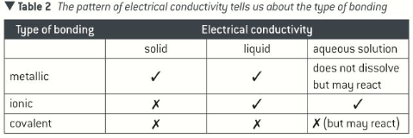
- ionic compound conduct electricity only in liquid state
- current is carried by the movement of ions towards the electrodes of opposite charge
- covalent bonded substances do not conduct electricity as they have no charged particles which are able to carry a current
- mostly insoluble in water and can react to form ions ex. Ethanoic acid
Melting and boiling points
- simple molecules – low melting and boiling points
- giant structured molecules – high melting and boiling points
Intermolecular forces
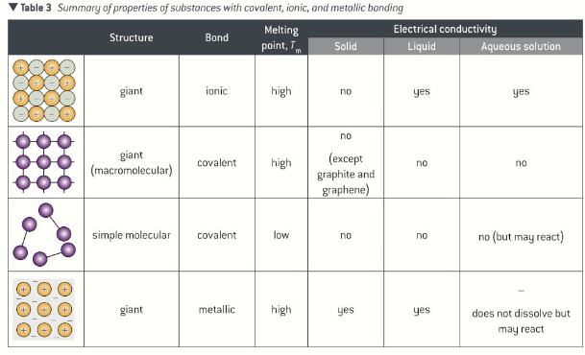
- strength of force determines melting and boiling points

