Breast Cancer
What is breast cancer?
Breast cancer is a malignant tumour that starts in the cells of the breast.
Causes
- Increased exposure to oestrogen
- If overweight/obese
- Being tall
- Drinks alcohol regularly
- Has been exposed to radiation

- Previous diagnosis of breast cancer
- Age
- Family history
- Particular genes (BRCA1 and BRACA2)

Symptoms
- Change in nipple appearance
- Lump in armpit
- Rash on/around armpit
- Dimpling of skin on the breast
- Change in colour of breast

- Change in size/shape of breast
- Nipple discharge
- Rash/crusting around nipple
- Pain in breast/armpit

Treatments
Medication – Radio Therapy, Chemotherapy, Biological Therapy
Surgery – Breast Conserving surgery, Mastectomy
Psychological – Counsellor or therapist and cancer support groups
Lifestyle Changes – Eat better, exercise, cut down on smoking and alcohol

Impact on Individual
Physical – Pain, Nausea, Fatigue, Anaemia, Lymphedema and fertility and sexual side effects
Intellectual – Lack in concentration, more knowledgeable on cancer
Emotional – Distress, anxiety, fear, depression and confusion
Social – Affect relationship with family or partner, get involved with raising awareness
Financial – Patients will go on sick pay.

Impact on Family
Physical – Feel or look run down, change in family identify and roles
Intellectual – Lack in concentration, more educated on cancer
Emotional – Feel happy they can give some support, upset their family has cancer, a bit helpless
Social – Take part in fundraising to help support family
Financial – May need to leave work to support the patient

Bowel Cancer
What is Bowel Cancer?
Cancer that begins in the large bowel
Causes
- Smoking
- Alcohol
- Bad diet
- Obesity

- Risk increases as you get older
- Family history
- Close relative diagnosed with bowl cancer

Symptoms
- Abdominal pain and bloating
- Weight loss
- Soreness

- A persistent change in bowel habit
- Blood in their stools
- Soreness and discomfort

Treatments
Medication – Radiotherapy and Chemotherapy
Surgery – Local Resection and Colectomy
Psychological – Counselling, Therapist, cancer support groups
Lifestyle Changes – Modify your diet, avoid spicy food, and maintain a healthy weight.

Impact on Individual
Physical – Pain, nausea, fatigue, anaemia and Lymphedema
Intellectual – May lack in concertation, but will be more educated in cancer
Emotional – Anxiety, fear, shock, anger, depression, upset
Social – Isolation from family, lack of contact from work colleagues, meeting new people, getting involved in fund raising
Financial – Have to go on sick pay, and rely on benefits

Impact on family
Physical – Feel or look run down, changes in family identity and roles
Intellectual – Lack of concentration, and more educated on cancer
Emotional – Feel happy they can give some support, upset their family has cancer, a bit helpless
Social – Take part in fundraising to help support family
Financial – May need to leave work to support the patient

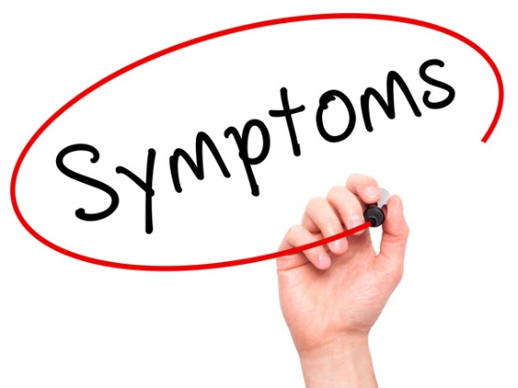
Testicular Cancer
What is Testicular Cancer?
It is Cancer of the Testicles
Causes
- Infertility
- Smoking
- HIV/AIDS
- Orchitis

- Undescended testicles
- Genetic mutation
- Endocrine hormone disruptors
Symptoms
- Dull ache/sharp pain in testicles/scrotum/groin
- Dull ache/pain in stomach/abdomen area
- Feeling of heaviness/pulling sensation in the scrotum/testicles

- Swelling or lump in testicle/scrotum
- Sudden collection of fluid in scrotum
- No symptoms other than exhaustion

Treatments
Medication – Radiotherapy (External and Internal) and Chemotherapy
Surgery – Lymph nodes surgery or Orchiectomy
Psychological – Can see counsellor or therapist, or cancer support groups
Lifestyle Changes – Cut down on smoking and alcohol and should maintain a healthy diet

Impact on Individual
Physical – Hormone Imbalance, Lower fertility, Lack of interest in sex
Intellectual – May lack in concertation, but will be more educated in cancer
Emotional – Feel less of a man, anxiety, sadness, anger and depression
Social – Isolation from family, lack of contact from work colleagues, meeting new people, getting involved in fund raising
Financial – Have to go on sick pay, and rely on benefits

Impact on family
Physical – Feel or look run down, changes in family identity and roles
Intellectual – Lack of concentration, and more educated on cancer
Emotional – Feel happy they can give some support, upset their family has cancer, a bit helpless
Social – Take part in fundraising to help support family
Financial – May need to leave work to support the patient

Leukaemia
What is Leukaemia?
Leukaemia is cancer of the white blood cells.
Causes
- Pre-existing vulnerability/family history
- Coupled with an environment trigger
- Certain blood disorders
- Certain genetic disorders

- Genetic mutation/mutation to the structure of DNA
- Stem cells produce more white blood
- Number of healthy red blood cells/platelets falls
- Exposure to significant radiation
Symptoms
- Excessive sweating
- Frequent unusual bleeding
- Bone and joint pain
- Fits/seizures
- Dizziness
- Blurred vision

- Pale skin
- Easily bruised skin
- Breathlessness
- Tiredness
- Weight loss

Treatments
Medication – Chemotherapy, blood transfusions, antibiotics, Fludarabine, Cyclophosphamide and Rituximab (FCR)
Psychological – Counselling, therapist, support and encouragement.
Lifestyle Changes – Treatment may have changed sense of taste, will need lots of rest.

Impact on Individual
Physical – Pain, Nausea, Fatigue, anaemia, Lymphedema, and fertility and sexual side effects in women
Intellectual – Lack in concentration, and more educated on cancer
Emotional – Stressed, anxiety, depression, shock, sadness
Social – Affect their relationship with partner and family, may go into raising awareness
Financial – Patient may have to go on sick pay.

Impact on family
Physical – Feel or look run down, changes in family identity and roles
Intellectual – Lack of concentration, and more educated on cancer
Emotional – Feel happy they can give some support, upset their family has cancer, a bit helpless
Social – Take part in fundraising to help support family
Financial – May need to leave work to support the patient

