Fiscal Policy

- Fiscal, monetary and supply-side policies are vital measures which authorities can use to achieve their four main macro-economic objectives: low unemployment, sustainable growth, low inflation and equilibrium in the balance of payments.
- Fiscal policy is the use of government taxation, spending and borrowing to influence AD.

Objectives of fiscal policy

- To improve macro-economic performance e.g. reduce unemployment, improve BOP or to reduce inflation.
- Achieve a more desirable redistribution of income
- Correct market failure e.g. provision of merit goods.

Crowding out

This occurs when increased government borrowing reduces investment. Financial crowding out happens when government expenditure diverts financial resources away from the private sector. If it spends more, it may need to borrow more – to raise this finance, it may need to increase interest rates (to attract people to buy their bonds, which are essentially an IOU). However, this deters private sector investment and consumption since it is more expensive to borrow.

Use of fiscal policy to manipulate AD

Orthodox classical economists think that the government should maintain balanced budgets – whatever the state of the economy. Any extra spending would crowd out private sector investment. If the government increased spending, this would displace private sector spending, giving zero net impact (increase in G is offset by fall in C and I), whether in boom or recession.

Keynes argued that crowding out did not take place in a depression. His views became the accepted convention of the 1950s and 1960s. The post-war government used fiscal policy to manage demand. Unemployment in those years was very low, therefore, it was the matter of using fiscal levers, so the economy could be manipulated towards full employment.

In later years, there was a monetarist counter revolution against Keynes. They argued theoretically, orthodox economists prior to the war were correct – crowding out neutralised the impact of fiscal policy on AD. There were also examples cited of economies who had increased unemployment and decreased inflation levels at the time.

Today, the mainstream view is that AD should be stimulated through monetary policy. Fiscal policy is best used to deal with other objectives of the government – e.g. correcting market failure/inequality, because of the limitations of FP in influencing AD.

Demand management
- FP can be used to manipulate the level of AD – known as demand management.

A larger budget deficit or a smaller budget surplus will increase injections in the economy through the circular flow. A budget deficit occurs when government expenditure exceeds tax revenue, which therefore increases GDP because injections become greater than withdrawals. This is as long as its expansionary effect is not negated by savings and imports (other withdrawals). This will be further increased through the multiplier process, according to Keynes.

The multiplier states that for every pound of extra deficit or reduced surplus, it will lead to a greater than increase in the final GDP.

Due to this increase, policies which inject into an economy are known as expansionary fiscal policy. Deflationary fiscal policy occurs where the government tries to reduce budget deficit or increase budget surplus – thus reducing AD.

Deflationary and expansionary fiscal policy should be used when there is an output gap, and the economy is in a recession. For example, expansionary policy should be used when the economy has very low inflation coupled with high unemployment at point A. Deflationary policy should be used at point B.
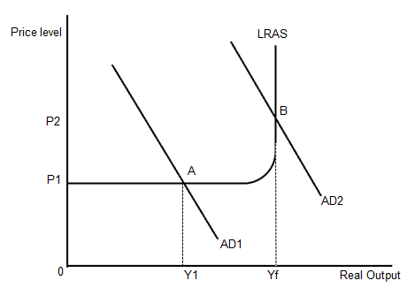
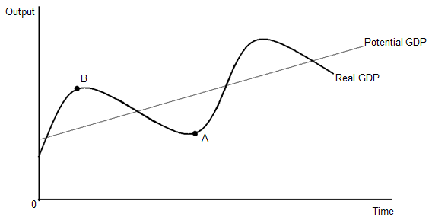

Keynes and taxation
- Progressive tax acts as an automatic stabiliser.

An automatic stabiliser is a mechanism which reduces the impact of changes in the economy or national income. Automatic stabilisers are tax revenues, welfare spending, and budget balance.

- When the economy is expanding, there is an increase in tax revenues – this takes money out of the circular flow – due to our progressive tax system. If an accountant found that their client’s income had risen, they may now pay a higher tax, reducing their disposable income. In a recession, the same accountant may move down their tax band to bring up some income.
- Welfare spending: A growing economy requires lower spending on benefits, whereas a shrinking economy will see welfare spending rise.
- Budget balance: During a recession, the government normally runs a budget deficit, and in a boom, creating a budget surplus. Therefore, manipulating injections and withdrawals to reduce the amount of AD.

Fiscal drag

When people's money income rises, dragging them into higher tax brackets. Fiscal drag is therefore referring to the effect inflation has on average tax rates. If tax allowances are not increased in line with inflation, and people's incomes increase with inflation then they will be moved up into higher tax bands and so their tax bill will go up. However, they are actually worse off because inflation has cancelled out their pay rise and their tax bill is higher. The only person that is better off is the Chancellor as he is getting more tax and hasn't had to increase tax rates. Chancellors have been known to use this as a subtle means to raise more tax revenue. To maintain average tax rates, allowances should be increased by the amount of inflation each year.

Examples of fiscal drag: stamp duty and income tax rate.

Inverse fiscal drag

When the economy is in a recession and national income is falling, employers move from higher levels of tax to lower levels. This helps to keep consumption high, but it also reduces government revenue.

Diminishing marginal utility

Keynes argued that progressive taxes would allow for a re-distribution of income from rich to the poor. This is important when considering fiscal policy. Poorer people tend to spend more of every pound they are given – they have a high marginal propensity to consume. Any extra given to the poor will have a greater impact on society than if it is given to the rich. However, a monetarist economist would argue against this – giving the rich more increases investment e.g. machines. If tax rates were lowered, it would provide rewards, stimulating entrepreneurship.

Monetarists and taxation

For monetarists, progressive taxation posed several problems.

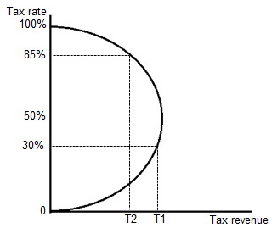
This system of taxation is a problem because the higher the tax for high income earners, the less the government will receive in revenue. Individuals may opt for leisure instead of work, and some may go to great lengths to avoid tax.

Issues in relation to progressive taxation

Crowding out:

- If the government increases their expenditure, they will need to increase taxation. As consumers and investors pay more tax, they have less money to consume or invest, illustrated by the Laffer curve.

Distorts signals in the labour market as a resource allocator (increased taxes reduce disposable income, and cause a ‘brain drain’ as individuals leave the country):

- Economic agents are attracted into different markets due to higher returns (e.g. wages). Tax placed on wages distorts their true monetary value in the marketplace. Some economic agents may be dissuaded from entering certain professions due to artificially low wages. This may stop the required increase in supply of labour to see a fall in this sector’s wage demand.
Keynesian economics

Keynes believed that aggregate demand and aggregate supply can be in equilibrium below the full employment in the economy.

For monetarists, the solution would be to reduce interest rates, thus reducing the exchange rate, to stimulate AD. Although Keynesians believe that this is important and should be done, they argue that on its own would be insufficient.

Liquidity trap

Keynes believed that higher government borrowing may not lead to higher IR, if the economy is in a deep depression. When there is a liquidity trap, borrowing can increase without IR increasing. This occurs as lenders are prepared to increase the supply of money without a rise in IR. Monetary policy alone cannot be used to get the economy out of the depression as IR is very low and consumers are not willing to borrow due to poor expectations they have about the future. A decrease in IR does not cause an increase in consumption or investment.

Keynes believed that in a deep downturn, we need not only monetary stimulus, but also a fiscal stimulus. And the government should budget for a deficit. His ideas of multiplier and accelerator are important.

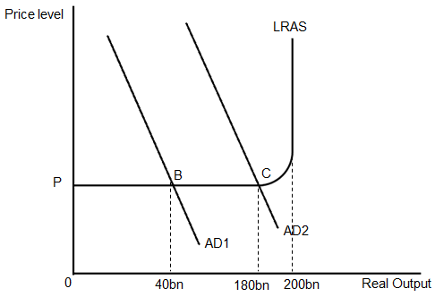

- The economy’s output is at point B – this is where AD and AS are in equilibrium. This is also at a point of deep depression, where only 40bn of output is being produced.
- However, the economy’s optimal position is at point C, which is closer to full employment, in which 180bn of output is being produced.
- Keynes argued to move from B to C, this would not require a 140bn stimulus because of the multiplier effect and the accelerator theory.
- In the multiplier theory, for every pound that is invested into the system, a greater amount than a pound would be yield in the economy.
- The accelerator theory states that whereas consumption is determined by national income, investment is determined by changes in the national income. It will affect a firm’s investment decisions as firms see an increase in consumption, they may invest, in the short term, in new machines and capital equipment. In the short-term, this would lead to a monetary increase in the physical capital – supporting the increase in consumption.

Criticisms of Keynesian economics

The idea of a very high marginal propensity to import (MPM)
- In the UK, we have a high MPM, when there is an increase in national income, UK citizens tend to spend this income on imports. When there is a fiscal stimulus, this does not necessarily cause an improvement in the economy.

The idea that budget deficits are not easy to finance
(Main criticism)

- The Bank of England sets the base rate – this is the IR it lends to high street banks and other financial institutions. However, governments and banks also lend to and borrow from each other.
- The rate they lend to each other is determined by LIBOR (London Interbank Offered Rate). If banks are concerned that the governments or other banks cannot pay debts owed, they may increase IR. Also, as the demand for money increases, the price of it will also increase (crowding out).
- Higher IR will decrease the willingness of the private sector to borrow and therefore consume or invest. So the incease in AD from a higher budget deficit will, to some extent, be offset by a decrease in AD from the fall in private sector borrowing (consumption and investment) – thus reducing the impact of fiscal policy.

- This shows that fiscal policy and monetary policy are interlinked.
- An increase in government borrowing may lead to an increase in IR. If the economy is in a deep recession, this may exacerbate the liquidity trap.

The idea that the demand for labour is not necessarily linked to the demand for goods and services

- When there is an increase in AD, there is not necessarily a change in the demand for labour. Any increase in demand for goods and services can be met through existing employees.

The idea that economics is not an exact science

Time lags:

- If the government announces 500m in civil servant salaries and a 500m increase in road building, and the multiplier is 2, this should lead to 2bn increase in output in the Keynes model. However, it will take years to work through. The increase in civil servant wages may be quick; the road programme may take several years to start.

- The government needs to be careful when it uses fiscal policy to correct a deflationary gap as the gap may have been eradicated when the stimulus begins to take effect. The government would reflate the economy just at a time when it was moving to a boom of its own accord – creating unwanted inflation.

Inadequacy of economic data

- Statistics are notoriously unreliable – often having black holes in data, residual errors and may be outdated.

Inadequate economic knowledge

- Active fiscal policy assumes we know how the economy behaves. There is scepticism that we will ever be able to predict changes in the economy.

Cyclical and structural deficit

We can examine the links between the government’s budgetary position and the level of economic activity, distinguishing between the cyclical and the structural components of a budget deficit.

- The cyclical deficit is a component of overall budget deficit which rises and falls with fluctuations of the economic cycle as automatic stabilisers take effect.
- In a downturn and recession, we expect tax revenues to fall but public spending on unemployment and welfare payments to rise.
- In an upturn, tax revenue rises and spending on unemployment and welfare falls.
- Therefore, over the course of an economic cycle, a rowing budget deficit would be cancelled out when economic growth occurs, providing it is sufficiently robust.

However, a structural deficit in the UK has resulted from a fundamental change in the structure of economic activity such as deindustrialisation and the growth of single-parent families increasing the number of households that are dependent on benefits (generalisation). The growing deficit suggests that governments wishing to improve public finances will need to significantly increase taxes or reduce public spending.

Public Sector Net Cash Requirement (PSNCR)

This is the term given to the government spending exceeding revenue (i.e. overdraft). To finance the gap between revenue and spending, the government borrows either from banks, insurance companies or individuals. The government does this through buying and selling bonds. A negative public sector net borrowing (PSNB) means that revenue exceeds expenditure and there is a budget surplus.

Does a budget deficit pose a problem?

- Fiscal crowding out
- An increase in the national debt – keeps expanding as debt is added up
- Financing the debt – the financing will incur interest, creating a leakage.

Possible benefits of a budget deficit

- Can increase AD through demand-management policies
- Stimulus to grow – long-term growth through infrastructure, education, which shifts LRAS.
  - Evaluation: Is it the government’s role?

Although monetary policy is currently the dominant policy used to influence the level of AD, fiscal policy does still have a role, especially in improving the supply-side efficiency of markets, helping to foster macroeconomics stability.

Current economic debates
How to increase economic growth

- The UK economy is currently lacking in AD – economic growth is negligible
- Government is under huge pressure to pay back massive budget deficit that has been accumulated over the past few years
- Markets have been impressed – government has a plan to pay back a large amount of this debt over this parliament. This has helped to keep the IR the government needs to pay on debt low.
- One of the measures the Labour government put in place before they left office was the 50% income tax rate levied on £150k+ salaries. Any extra tax revenues would go to pay off the debt.
- Economic growth is stalling and pressure is being put on the government to stimulate the economy through AD/AS
- Some Keynesian economists argue VAT should be cut from 20% (Jan 2010) to 17.5% (Ed Balls) to try to increase consumption, a main component of AD to increase AD. He argues that decreasing VAT should be paid for by increasing time to pay back deficit. Keynesian economists would argue, due to the multiplier, any increase in injections will have a greater than itself impact on GDP
- Other policies put forward by Balls were to cut in capital gains tax (tax for firms to pay on profit)
- Some economists argue that there should be a decrease in the 50% income tax rate. They suggest that whilst this extra tax will help to pay off pubic deficit (report to be published Jan 2012 as to whether the higher tax rate does actually increase tax revenues – Laffer) and it helps to keep tax rates lower for those poorer in society. (Those who are poorer, tend to spend more of their income, keeping it in the circular flow. If this marginal income is given to the rich, they may save I, creating a withdrawal from the economy).
- Monetarists argue that if tax rate were to fall to 50%, it would allow the richest to invest in firms and entrepreneurship to invest in the economy. This increase in investment would not only shift AD (in the short term) but in long term shift LRAS, altogether improving the productive capacity of the economy, At present, the top 11% income earners pay 20% in all income tax.
- Some economists also point out at the 50% income tax rate may create a ‘brain drain’ as highly skilled labour leave the UK due to higher tax rates. This brain drain would decrease LRAS and thus the output potential of the UK.

