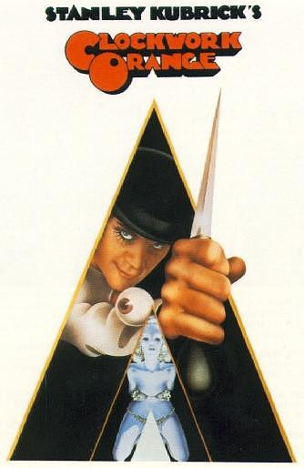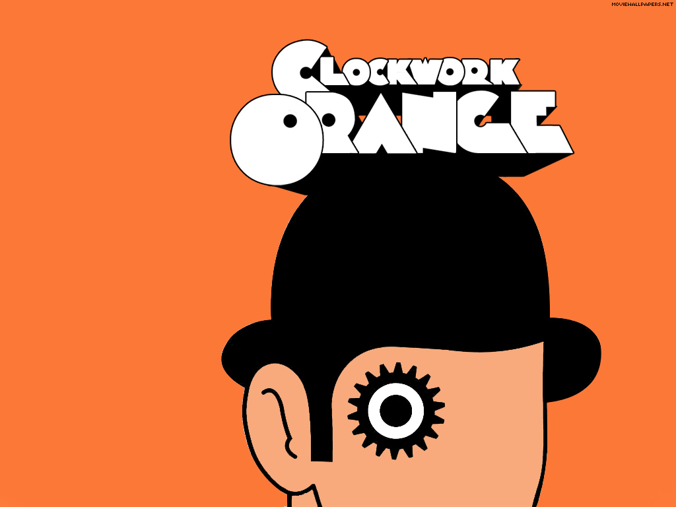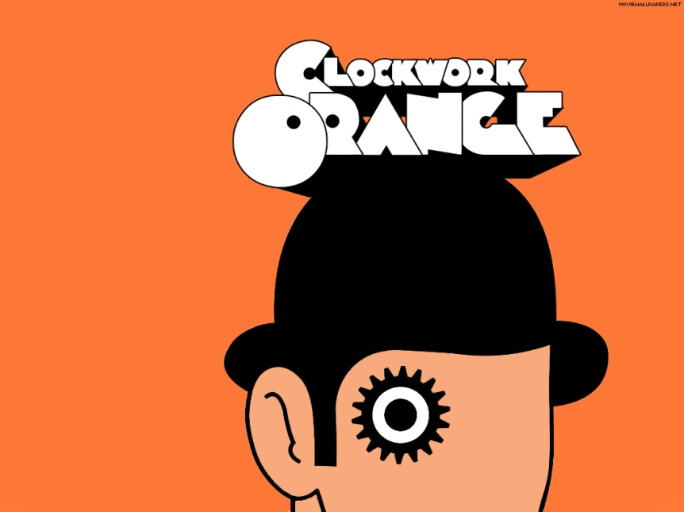

G L O B A L R E C E P T I O N

Along with *Bonnie and Clyde* (1967), *The Wild Bunch* (1969), *Dirty Harry* (1971) and *Straw Dogs* (1971), the film is considered a landmark in the relaxation of control on violence in the cinema. In the United Kingdom. In the United States, *A Clockwork Orange* was rated X in its original release form. Kubrick later, voluntarily, replaced some 30 seconds of sexually explicit footage, from two scenes, with less bawdy action, for an R rating re-release in 1973. Current DVDs present the original X-rated form, and only some of the early 1980s VHS editions are the R-rated form. The National Catholic Office for Motion Pictures rated it *C* ("Condemned") because of the explicit sex and violence. Conceptually, said rating of condemnation forbade Roman Catholics from seeing *A Clockwork Orange*. In 1982, the Office abolished the "Condemned" rating; hence, films the Conference of Bishops deem to have unacceptable sex and violence are rated *O*, "Morally Offensive".

T H E B R I T I S H W I T H D R A W A L

The British authorities considered the sexual violence extreme, furthermore, there occurred legal claims that the movie *A Clockwork Orange* had inspired true copycat crimes, as per press cuttings at the British Film Institute. In March 1972, at trial, the prosecutor accusing the fourteen-year-old-boy defendant of the manslaughter of a classmate, referred to *A Clockwork Orange*, telling the judge that the case had a macabre relevance to the film. The press also blamed the film for a rape in which the attackers sang "Singin' in the Rain". Christiane Kubrick, the director's wife, has said that the family received threats and had protesters outside their home. Subsequently, Kubrick asked Warner Brothers to withdraw the film from British distribution, disliking the allegation that the film was responsible for copycat violence in real life. The Scala Cinema Club went into receivership in 1993 after losing a legal battle following an unauthorized screening of the film. Whatever the reason for the film's withdrawal, for some 27 years, it was difficult to see the film in the United Kingdom. It reappeared in cinemas, and the first VHS and DVD releases followed soon after Kubrick's death in 1999.

O V E R V I E W

A Clockwork Orange is a 1971 film adaptation of Anthony Burgess's 1962 novel of the same name. It was written, directed and produced by Stanley Kubrick. It features disturbing, violent images, facilitating its social commentary on psychiatry, youth gangs, and other social, political, and economic subjects in a dystopian, future Britain.

R E L E A S E D E T A I L S

**Directed by:** Stanley Kubrick

**Produced by:** Stanley Kubrick

**Screenplay by**: Stanley Kubrick

**Based on:** A Clockwork Orange

by Anthony Burgess

**Narrated by:** Malcolm McDowell

**Music by:** Walter Carlos

**Cinematography:** John Alcott

**Editing by:** Bill Butler

**Distributed by:** Warner Bros.

**Release Date:** January 13 1972 (UK)

February 2 1972 (USA)

**Running time:**  137 minutes

**Country:** United Kingdom

**Language:** English

Nadsat

**Budget:** $2.2 million

**Box Office:** $26,589,355

