Child Language – Learning to talk
- Once argued to be a biologically determined process alongside physical and mental growth.
- Cannot be true because children deprived of human contact in extreme human isolation do not acquire language.
If language were innate and liked only to biological factors, even after isolation, then the appropriate triggers would help children acquire language in the same way, though this is not the case.
- It seems language acquisition is dependent on appropriate linguistic input which must be gained before a certain age.
Behaviourist approach of language acquisition (Skinner)
- Based on conditioning and reinforcement. When a child imitates language and receives attention, this motivates the child to repeat the behaviour.
- Children learn to speak by imitating the language structures they hear. Parents reinforce and correct utterances which forms the basis for a child’s knowledge of language.
- Although important in learning pronunciation and acquiring vocabulary, children don’t pick up ‘correct’ forms from imitation
- With irregular verbs, for example, children’ don’t use the standard form because they hear adults use it. Instead, they over-extend the language patterns they already know:
Steal Stealded (stole) Grow Growded (grew)
- Although children may add new words to their repertoire by using labels (a word with a naming function) an adult has introduced, they rarely imitate speech that is not directed at them.
- Children don’t assimilate syntactical structures by imitation
- Fails to explain how children produce structures they haven’t heard before

Cognitive approach of language acquisition (Piaget)
- The cognitive approach links language acquisition to intellectual/cognitive development, suggesting that children can only use a certain linguistic structure when they understand the concept involved.
- E.g. Children will only understand the past tense when they have understood the concept of past time; so children must recognise and conceptualise vital physical differences before they can talk about shape and colour
- Children’s knowledge is structured differently to adults. It changes from infancy to adulthood in a similar way for everyone. Due to maturation, there are changes in understanding, therefore they are determined biologically- however it is via interaction with the world around them that their intelligence develops. Because of this, Piaget proposed that children’s thinking develops in 4 stages: Sensimotor, Pre-operational, concrete and formal stage.

Age range | Description of stage | Developmental Phenomena
0-2 years | Sensorimotor- Baby explores through 5 senses. Initially grasping, sucking reflexes. Grabbing objects and exploring it with mouth.  These skills develop and become more complex | Object Permanence – The awareness that an object exists even though not visible. Shake a rattle and gain attention of 3month old then cover it with cloth = no longer interested. Repeat with 8month old and child shows distress at its disappearance.
2-6 years | Preoperational- Child begins to use symbols/signs/objects to represent things | Animism/pretend play – Give an inanimate object feelings.  Egocentrism – Seeing the world from child’s perspective & world is an extension of oneself. When playing hide and seek, if you child can’t see you, you can’t see child.
7-11 years | Concrete Operational – Child thinking logically about concrete events and grasping concrete analogies. Can understand something is the same, though different appearance. | Conservation- 4year old child will focus on what they see, not what they know. When presented with one tall narrow glass and a short fat glass (both with the same amount of water), the 4 year old will say the tall narrow one has more because it looks so. A 7year old can identify there is the same amount.
11+ | Formal Operational Stage – Thinking about hypothetical scenarios and processing abstract thoughts. Child can manipulate ideas in heads and creatively imagine outcomes of problem solving.  Piaget thought when this stage began the structure of thinking would stop, though complexity/flexibility and level of abstraction keeps growing with age. | 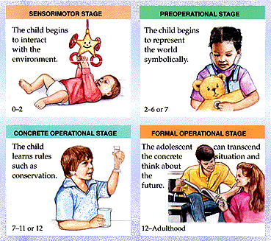  Abstract logic – Piaget gave child containers of different liquids, one of which called ‘the indicator’. The child had to find a combination that would turn the indicator yellow. Child would systematically solve the problem, whereas younger child would test in a ‘haphazard way’.

- As a way of responding to Chomsky’s LAD learning system, Bruner theorised the Language Acquisition Support System (LASS) which he states that through LASS, parents often use books and images to develop the child’s naming abilities and their ability to get involved in conversation. LASS = Gaining attention (drawing the baby’s attention to a picture), Query (Asking the baby to identify the picture), Label (Telling the baby where the object is), Feedback (Responding to the baby’s utterances).
- In his research on the cognitive development of children, he proposed 3 models of representation which are the way in which information/knowledge is stored or encoded.
Nativist approach of language acquisition (Bruner)
- Bruner believes the child has to learn for itself by making sense of its own environment. Language development comes easier to most children because of a combination of ‘innate biological endowments’ and social encouragement. The role of encouragement is to provide necessary support at the child develops linguistically

Cognitive approach of language acquisition (Vygotsky)
- Sociocultural theory combines cognitive & social development. Emphasised the importance of relationships between children and (more knowledgeable) adults.
Children’s cognitive understandings and enriched and deepened when scaffolded by parents, teachers or peers.
- He is associated with the Social development theory which stresses the role of social interaction in the development of cognition.
- Saw the adult as vital to the process of scaffolding of child’s behaviour (support it structurally while internal developments occur). They develop skills and strategies.
E.g. Bonnie is completing a three-piece puzzle with knobs on top. She has the last piece over the right space but is upside down (won’t fit). She pushes harder. The caregiver says ‘Try turning it, Bonnie’, but Bonnie looks confused. The caregiver puts her hand over Bonnie’s and turns the piece slightly, saying ‘See, Bonnie? Turn it’.
By careful scaffolding, her zone of proximal development has expanded.
- Different to Piaget because didn’t see the child as a solitary discoverer of knowledge, but as learning within social interactions that involve communicating (role of language is important!)

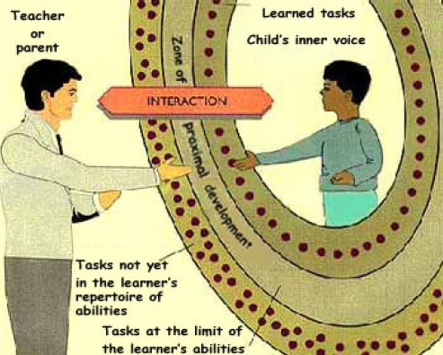
- Similar to Piaget because he saw children as active in their own learning, and increasingly so as their ability to interact with others develops.
- Also coined Vygotsky’s Zone of Proximal Development. In simple terms, when a student is at the ZPD for a particular task, providing (sometimes small) appropriate assistance will give the student enough of a boost to achieve the task.

Vygotsky (again) identified four stages of speech development

Primitive speech stage | Birth -2 years : During this stage, the child begins to learn to speak, mainly imitating words & naming objects, or responding emotionally (crying) or socially (laughing)
Naive psychological stage | 2-4 years :The child in this stage is beginning to realise that words are symbols for objects. They have great curiosity as to what objects are called
Egocentric or private speech stage | 4-7 years : Children often talk aloud to themselves as they perform tasks or solve problems in this stage of development. This ‘private speech’ is the child’s demonstration of their thinking
Ingrowth or inner speech stage | 8+ : Children’s private speech declines and becomes internalised. Solve problems in their head or inner speech.

Nativist approach of language acquisition (Chomsky)
- Children have an innate ability to learn language – an inbuilt ‘Language Acquisition Device’ (LAD) which is wired to help them learn language. Once they begin to learn language around them, nativists suggest that children have conceptual schemes which are programmed to already understand the structure of the language.
- The language exposed to simply fits in with the innate ‘blank’ concepts, thus the theory emphasises the need for language in the environment to stimulate children’s innate abilities.
- Chomsky focuses on biological dispositions, brain development and cognitive readiness
This links to children over regularising and putting grammar into utterances when not needed

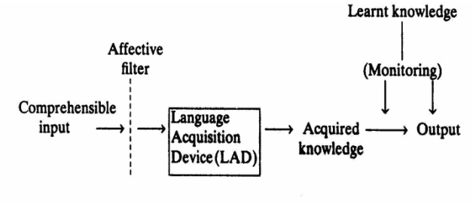
The LAD contrasts to Skinner’s
behaviourist approach which emphasises principles of learning such as classical and operant conditioning over biological
predisposition.
Bruner and Piaget emphasise the importance of the interaction between biological and social (nature and nurture) aspects of language acquisition.

Interactive approach to language development
- Adults alter the way they talk to their children (CDC), giving them specific opportunities to take part in their discourse. Utterances are simplified, intonation patterns are distinctive and extra information is given for clarification.
- Vocabulary is simplified so that concrete objects are named in broad categories (overextension) Dog instead of Labrador, ball instead of football. ‘Baby words’ such as doggie or moo-cow don’t help efficient language learning, however reduplication of sounds such as bababa and dadada enables more communication because easier to say.
- Conversations tend to be based on concrete things that relate directly to the child’s environment
- Sentence structures tend to be short and often use pauses at the end of clauses. Certain sentence patterns occur often: Where is ____? You want ____? That’s (pointing) a ____
- Commands occur frequently and young children assimilate them in their own speech
- Tag questions questions added to the end of a statement inviting a response from the listener Isn’t it?, Aren’t we? – invite direct participation and encourage children to ask for clarification if needed.
- Repetition reinforces new words or structures and clarifies meaning
- Pitch is usually high to keep a child’s attention. Singsong intonation and exaggerated stress on key words make words more important.
- Pace is usually slower for young children.
Children receive attention as a direct result of any communication attempts, so the process is rewarding. ‘Caretaker speech’ is important to create a positive relationship.

How to use theorists and concepts?
In the exam if you get a transcript of child’s speech, you could talk about Child Directed Speech (or caretaker language). As for a cognitive approach, you could talk about if a child is discussing abstract ideas (emotions and ideas that aren’t physical), because only they’d understand them if they understood the concept first (comprehension before application)
To apply a behaviourist approach; if a child was imitating in the conversation unusual they’ve copied off someone, that can be an example of role modeling. If a child is overextending the inflection ‘-s’ to make ‘feets’, they’ve not finished learning through trial and error, so a nativist approach can be used here.
Another way to discuss a nativist approach is if the child adds the suffix ‘ed’ onto a verb which does not make sense –I drawed instead of I drew which cannot be taught to the child, the child must have used past information and applied it to recent information without a prompt, suggesting it is innate.
You can get marks if you discuss things that contradict a theory, not always support one. If a child shows none of these theories it can be pointed out how it doesn’t support any (still shows understanding).

Basic principles of all the above theories
They all highlight a particular element of child language acquisition, but none can provide a full explanation on their own.
Their basic principles are that:
- To acquire language, children must be part of a social and linguistic community
- Physical development plays a part in the children’s ability to articulate the particular phones making up a language
- Children have some kind of instinctive awareness of language patterns which allows them to experiment with structures that they haven’t heard before.
- In order to use language structures (like the comparative for example: This toy is better than that toy), children must be able to intellectually conceptualise the world around them – language acquisition is therefore linked to intellectual development
- Through imitation children acquire new vocab and may be introduced to new grammatical structures
- Parental reinforcement highlights non-standard usage and draws attention to ‘correct’ versions- although children often don’t accept adult correction and too much can be detrimental. (Fis phenomenon)
- Especially adapted forms of speech create a positive speech environment in which children are encouraged to participate in a meaningful way.
What’s the function of communication in child language acquisition?
Interaction with other people gives children a purpose – if they can acquire language, they will be able to participate in the communication going on around them.
It usually starts by using different kinds of cries to attract attention to their needs, but as they grow they use more complex methods. As a result, they can:
- Establish a relationship with people around them
- Express feelings/opinions
- Get others to do as they wish
- Find out new information by asking
- Get what they need by explaining exactly what they want
- Communicate ideas
- Tell stories and use language expressively
Michael Halliday’s taxonomy catalogues the different functions of language in the growing child’s repertoire. Pragmatics
Type of function | Description | Example
Instrumental | Language used to fulfil a need on the part of the speaker. Directly concerned with obtaining food, drink and comfort so mainly concrete nouns are used. | ‘’Want juice’’ when a child is thirsty
Regulatory | Language used to influence the behaviour of others by persuading/commanding/requesting other people to do something for you | “put down!” when child is holding up father
Interactional | Language used to develop social relationships and ease the process of interaction. Concerned with the phatic dimension of talk because a child realises language goes beyond declaring what you want | “Night night daddy, love you” as the child is being put to bed
Personal | Language is used to express a personal preference and identity of the speaker. Sometimes known as the ‘Here I am!’ function by announcing oneself to the world | “Me like that” as the child looks at a toy in a shop.  “No” because the child wants to stay in the park
Representational | Language used to exchange information. Concerned with relaying or requesting information. | “Mummy” as the child’s mum returns home from work
Heuristic | Language to learn and explore about the environment. Child uses language to learn, may be questions and answers, or the kind of running commentary that sometimes accompanies child play. | “Why?” when the child is told to put his shoes on
Imaginative | Language used to explore the imagination. May also accompany play as children create imaginary situations, or may arise from storytelling | “I’m superman” whilst the child plays

Similarly, John Dore describes language functions that focus more on individual differences- ‘Infant Language Functions’
Infant language function | Description | Example
Labelling | Naming or identifying a person, object or experience | “Mummy” when mother returns. “Me like that” when seeing a toy in shop”
Repeating | Echoing something spoken by an adult speaker | “Night night daddy I love you” when being put to bed
Answering | Giving a direct response to an utterance from another speaker | “Me like that” when looking at a toy
Requesting action | Demanding food, drink, toy, assistance | “Why” Response to a question. “want juice” when thirsty. “Put down” when being picked up
Calling | Attracting attention by shouting | “I’m wet” when it starts to rain
Greeting | Saying hello | “Hello”
Protesting | Objecting to requests | “No” wanting to stay in park “put down” when being picked up
Practicing | Using and repeating language when there is no adult present | “hello Mr. Pig” playing with toys
- For politeness, Brown and Levinson’s face can be applied (communicative interaction
Positive- individual desires social approval and being included
Negative- individual asserts need to be independent and make own decisions.
- For pragmatics, Catherine Garvey found that in play, children adopt roles and identities, acting out storylines and inventing objects and settings.
This is termed pretend play and fulfils Halliday’s imaginative language function
Play practices social interactions and negotiation skills, with players’ roles and responsibilities often decided as they play.
- Sometimes known as sociodramatic play, it involve sboth social and dramatic skills, with explicit rules reflecting real-world behaviour.
Begins around 4, linking in with cognitive understanding as they understand different roles need their language adapted. Specific lexis & structure supports imitations of adults.
Stages of development
Pre-birth
- It’s possible that in the womb that have already become accustomed to sounds of the native language
- When a child is born, it cannot speak or understand, yet it can recognise its mother’s voice Evolutionary advantage – Stay closer to mother, know that mother can protect & feed as primary caregiver.
- Babies become familiar with rhythms and intonations
- DeCasper found that babies sucked on their dummies more when their mothers read stories to their children= recognition
- Mehler (1988) found that French babies increased sucking of dummy when listening to French when comparing sucking motion to English or Italian
- Fitzpatrick Unborn baby heart rate reduced when hearing mother’s voice
- Chomky said that pre-natal babies have innate abilities to acquire language. Children combine the language they hear with the innate knowledge they have in their head (LAD).
The baby already knows about linguistic universals and hears examples of language in its native language.
- This helps babies to hypothesise about incoming language: e.g. that grunt is irrelevant, those words always have an –ing gerund on the end
After birth (vegetative)
Usual responses summarised by David Crystal:
- Biological noises – Universal across all languages as a
survival attention instinct
- Cooing and laughing – short vowel like sounds.
Beginning to develop control over vocal muscles
- Vocal play – More varied but less controlled
- Babbling – Produces phonemes, often in combination of vowels and consonants Go, ma, pa, la, sa
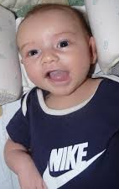
Stage one (0-8 weeks basic biological noises)
- Vocal sounds reflect biological stages and activities
hunger, pain, discomfort = causes crying/fussing (reflexive noises)
- Vocal folds vibrate strongly, pitch falls sharply- quality similar to [a]
- Not easy to attribute different functions to cries at this early stage
- Nothing language specific about noises. Some features in common
with later speech- rhythmical vocalisation, air stream to produce noise
- Phonology is learning to use verbal equipment- air stream from vocal organs to create rhythmic sounds, familiarising infants with process involved in later speech
- Pragmatics- a child will learn different screams to give basic different responses from parents and the basics of turn taking

Stage two (8-20 weeks cooing and laughing)
- By 6-8 weeks cooing sounds will emerge often triggered by social interaction with caregivers and resemble the production of vowels
- Develop with crying and become more frequent/varied – responding to mother’s speech/sound
- Quieter and lower pitched – Consonant vowel [gu] [ga] – using the back of the mouth
- Using tongue to produce sounds, lip movement- imitation?
At 4 months they develop a throaty chuckle

Stage 3 (20 weeks-30 weeks vocal play/verbal scribbling)
- Steadier and longer sounds
- Experimentation to push what they can do (pitch, volume, sounds)
- Individual differences- some days use uvular sounds
(rolling Rs, inner mouth), but others use labial sounds (lips)
- Eventually combine and produce babbling
- Variety of vowel and consonant-like sounds which combine
into increasingly longer sentences.
- Rising pitch contours require raised subglottal pressure to
increase vocal fold length or tension at the end of vocalisation

Stage 4 (25-50 weeks canonical babbling)
- Less varied than vocal play, less experimentation but more control- smaller sets of sounds, yet greater frequency and stability to produce. Bababada – reduplicated babbling containing consonant vowel (CV) syllables
- Half way through this stage, the child develops variegated babbling – consonant and vowels change from one syllable to the next [ado]
- Previously there would be no visible link between babbling and spoken language, previously random manner babbling until speech began.
- Babbling still goes on after 18 months, but they’re not randomly produced sounds- the brain appears to be controlling the development of babbling and early speech in a similar way.
- So, a set of well-practiced sounds are available when the child is intellectually capable of using the sound to communicate meaning
- The number of phonemes produced are increased, known as phonemic expansion, then decreased through phonemic contraction to retain sounds of the native language but discard those not needed.
- Noises made serve a function to their physical condition. If they cry they are hungry or need changing. They need to control the flow of air to make these noises and this same control will be used in a more refined way as their abilities to communicate become more sophisticated
- React to parental smiles and produce coos. It’s softer than crying,
made up of velar sounds like [k] and [g] and high vowels like [i].
- Understand the different tones of voices- anger, pleasure, humour.
- Their own laugh encourages more varied responses from parents, widening
the scope of possible interaction (Skinner- positive reinforcement to laugh more).
- Physical development: as the child looks around and sits up, parents point things out and their intonation becomes exaggerated
- Peekaboo makes interaction fun
- Vocal chords are used in conjunction with the movements of the tongue- it starts to move horizontally and vertically enabling a wider range of sounds.
Pitch level is usually high but also marked by glides from high to low as the baby experiments

Stage 5 (9-18 months melodic utterances) Two word stage
- Variations in melody, rhythm and tone of voice are a major feature of utterances towards the end of the child’s first year.
- Parents begin to pick up on the child’s intentions
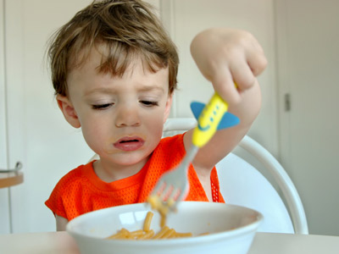
- Individual syllables are used with a fixed melody- producing proto words where sounds are clear but meanings are not- express specific meanings, but not real words in the target language
- These are the first signs of language development and
when children growing up in different language environments
begin to sound differently from one another
(accent, pitch, intonation, tone).
- They understand words and point towards certain parts
of their bodies like ‘ear’ and ‘nose’.
- Will look for things when asked to, for example ‘Get your hat’.
- Make gestures or ask for ‘more’ or ‘again’
- First words are formed but the language used at this stage doesn’t resemble adult speech, but parents familiar with the context may be able to recognise proto-words
- From 12 to 18 months onwards, children begin to produce a variety of recognisable single word utterances based on everyday objects. These utterances are holophrastic- they are grammatically unstructured and each consist of a single word.
- Pronunciation is often idiosyncratic.
- Acquire around 10/20 new words a month, mostly with a naming function (food, toys, body parts, clothing, household objects). During the holophrastic stage children use a limited vocabulary to refer to a wide range of unrelated things.
- Overextensions are therefore common (to refer to the same word for different objects similar in size, shape, sound or movement – e.b. baby for all children, or flower for anything with leaves.
- As the child gains linguistic experience, overextensions are replaced with a narrowing field of reference because more words have been learnt
- Other examples of a lack of linguistic sophistication at this stage are:
Under extension- words are given a narrower range of reference than is usual- car may be used to refer to the family car only
Mismatch is when a word is used to label objects with no apparent logic – doll and child’s trousers

Stage 6 (18 months-24 months) There will be crossover in years depending on the child’s individual differences and pace of development
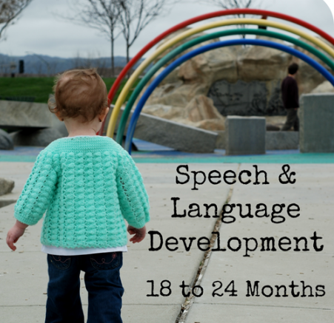
- Vocabulary of +200 words.
- Pronunciation is still a bit erratic, but its standardisation takes place over
an extended period. It will take another 12 months to pronounce the
voiceless labiodental fricative [f], the voiced bilabial approximant [w].
- Although 2 words are spoken they are mostly used as a single unit.
Words are used as distinct rhythmic units and can be analysed as
grammatical sequences
(baby) (go) (dummy) (there) (Eat) (apple)
Subject-Action Subject -Action Action-object
- These minimal structures means the child can describe a range of things. Adults respond to such utterances even when they are neither grammatical nor complete, thus the child becomes a part of real communication. The parent can often determine the meaning from the context and from the child’s intonation.
- An utterance such as Jo-Jo cup may mean:
This is Jo Jo’s cup (possession)
Give me my cup (Command)
Jo-Jo has got his cup (statement)
Where is Jo Jo’s cup? (question)
- Children will also use inflections
- Will also experiment with the present participle, though not used correctly until a few years later.
- Negative words emerge (no and not are used as one word sentences or are tagged onto the beginning of an expression: no (in response to a request); no sit; not car.
- Can point towards a picture or a sign, such as Where is McDonalds? Understanding of proper nouns
- Feedback is important because it establishes them as participants in ‘real communication’. Because parents respond to all utterances even if they do not appear to be meaningful, children are encouraged to experiment and therefore work out what Is and what is not acceptable through trial and error.
Stage 7 (24 months – 30 months) telegraphic speech
- Understand more than they can say
- Important lexical words to express ideas and a grammatical function (e.g. prepositions, determiners (a& the) , auxiliary verbs (indicating tense has, do) and inflections) are often omitted.
- Vocabulary expands very quickly and initiates talk rather than monologging.
- Pronunciation becomes closer to the standard adult form.
- Utterances become longer and clause elements are less likely to be deleted
- Inflections are used more frequently and more accurately:
-s to mark plural nouns: sheep sheeps; information informations
-ed to mark regular past tense: Steal stealed; go goed; build builded
- Auxiliary verbs are still often omitted, but usage becomes more accurate
Little pigs always having fun It be chugging in the tunnel
- Modal auxiliaries are used more frequently to convey variations in attitude
Frog might have a swim We will need a ladder
- Present participles are often used with primary verb to be. Wh-questions words are tagged onto the beginning of an utterance: what? And where? Are first used, followed by why? And later how? And who?
- Negatives are used subtly too. Additional contracted forms like can’t and won’t also appear alongside no and not. Also placed alongside a verb, rather than always at the start of an utterance. I not tell story I can’t know It’s not Lexie’s
- Pronouns are used with more variety, but often inaccurate. Because they hear themselves referred to as you, they tend to use the second person pronoun to refer to themselves. Similarly, I the first person singular is used to refer to others.
This shows the importance of imitation; although they sometimes know instinctively their meaning is unclear, they use gestures to clarify the reference. (this also happens with possessive determiners (e.g. my, your, her).
- After becoming familiar with pronouns and determiners, they correct themselves. They repair a breakdown by repeating the utterance with a word changed:
This toast is for you (.) toast is for me

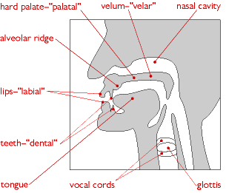
Phonological development
How the child develops the ability to understand the sounds of language
It’s difficult to be precise about later phonological development and the way in which vowels and consonants are acquired because it varies from child to child. When a sound has been mastered, it maybe is used only in the pronunciation of certain words yet missing or pronounced incorrectly in other words.
Researchers have identified certain trends in phonological development:
- Control of vowels comes before all of the consonants
- By the age of 2 ½, the average child will have mastered all the vowels and 2/3rds of the consonants
- At 4, the child is likely to have difficulty with only a few consonants
- The child may be six or seven before confident in using all vowels and consonants
- Consonants are first used correctly at the beginning of words but consonants towards the end of words are much more difficult, for example ‘p’ and ‘b’ sounds in ‘push’ and ‘bush’ will be easier than ‘rip’ and ‘rib’
- In general, sounds that occur frequently in a large number of words will be acquired before sounds that occur less frequently
- To make words easier to say, children simplify their pronunciation using certain techniques

Ways of simplification
Deletion | Children will often simplify pronunciation by deleting certain sounds.  When an adult word ends in a consonant, a baby will miss it out such as ‘ca’ in ‘cat’. In words of more than one syllable the beginning of the word is more likely to be deleted than the end.  Unstressed syllables are often deleted ‘banana’ becomes ‘nana’.  Consonant clusters are reduced, such as ‘snake’ becomes ‘nake’ and ‘Sleep’ becomes ‘seep’.
Substitution | Another form of simplification involves substituting harder sounds with easier ones. For example R (in Rock or stoRy) becomes w; Th (as in There, That or Thumb) becomes d, n or f; T (as in Toe) becomes d; P (as in Pig) becomes b.  Often babies will avoid consonants that involve friction (the ‘sh’ in ‘ship’) in favour of one involving a stopped sound (the ‘t’ in ‘top’). So ship might come out as tip.
Addition | This often involves the addition of an extra vowel sound to the end of a word. So, egg might become ‘egu’
De-voicing | This is the process of taking the voice out of b to produce p. Babies prefer de-voicing at the end of words so that ‘pig’ might become ‘bik’
Voicing | Naturally, the opposite of de-voicing so that at the beginning of words babies are more likely to produce an unvoiced consonant, as in ‘pig’ becoming ‘bik’
Assimilation | This happens when one consonant becomes similar to another, as in ‘gog’ for ‘dog’.
Reduplication | Reduplication of sounds is another common phenomenon. This refers to the repetition of the whole syllable, as in ‘choo-choo’
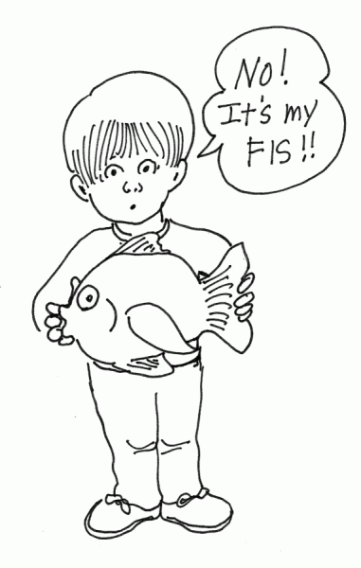
Berko and Brown described how a child referred to a plastic fish as his ‘fis’. When an adult asked him ‘is that your fis?’ he replied ‘no, my fis’.
Another child confused card/cart & jug/duck in a similar situation when shown pictures of items. This shows that the child understood and knew what the child wanted to say but was unable to replicate it & was aware that the parent was not saying it right.
This proves that understanding may develop faster than the ability to pronounce things as children are still refining their motor skills.
- Individual speech sounds are called phonemes
- They vary upon language, dialect and accent because each language uses a particular selection of phonemes from the repertoire of sounds made by the human vocal tract.
- In English there are 20 vowel sounds (though only the vowels a,e,i,o,u exist) and 24 consonants (44 phonemes in total)
- Some sounds are apparent in early babbling, while others may appear much later, long after the child has started using recognisable words.
Too, two & to are all homophones (words that are pronounced the same but have different meaning and spelling
- It’s not only just about individual sounds, speech requires combining them in a variety of ways, characteristic of the particular language or dialect the child is learning.
One feature is to use consonant clusters
Glimpsed the word is pronounced /glɪmpst/ which begins with two consecutive consonants and ends with 4.
A child will find it difficult to miss out a few syllables to convey what they mean without communicating, so they use prosodics and pragmatics instead to convey meaning.

International Phonetic Alphabet (IPA) 1886
The IPA is an alphabetic system of phonetic notation based on the alphabet. It aims to standardise the representation of sounds of oral language. English spelling conventions are not consistent enough to be used in a systematic phonetic transcription, so as a result the IPA was invented..
The same letter or letter combination can refer to different sounds: low vs cow vs row vs sow. Although similar spelling, different phonology.
We can’t use the alphabet to represent sounds because it’s too inconsistent cow, bough, sound.
- In the context of the IPA each sound has a certain symbol
- A different symbol for each distinctive sound
- The same symbol should be used for that sound in every language with uses it
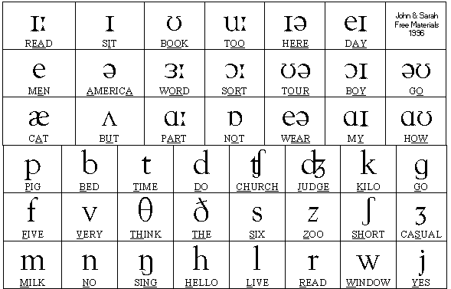
- Diacritics for more minor modifications (diacritical marks are attached to a letter or abstract to distinguish it from another).
How sounds are produced
Air passes through the vocal chords
The production of consonants is affected by:
- If the sound is voiced or unvoiced (by vibrating or not vibrating the vocal chords)
- The place of articulation (where it occurs); to make sounds we can use our lips, tongue, teeth and the roof of our mouth, or combine these
- The manner of articulation (how the airstream is controlled)
Place of articulation:
Labial | /p/ ‘pat
Labio-dental | /f/ ‘fit’
Dental | /θ/ ‘thin’
Alveloar | /t/ ‘tin’
Post-Alveloar | /ʃ/ ‘fish’
Palatal | /j/ ‘young’
Velar | /k/ ‘kick
Glottal | /h/ ‘hit’

Vowels Consonants
Manner of articulation (Air flow obstruction)
- Plosives- complete obstruction or stop
e.g. b d g p t k
- Fricatives – Close obstruction involving friction
e.g. θ (thin), ðɛn (then), s, f
- Affricatives – two elements in quick succession. Consonant begins as a plosive and ends up as a fricative
e.g. itchy (ɪtʃi), edgy (ɛdʒi), judge (dʒədʒ) [dʒ]
- Nasal – Complete obstruction of air flow in mouth, but open velum (the velum allows air to escape from the nose instead)
e.g. Mat
- Dipthongs – Sounds that begin as one vowel and end up as another (changed by gliding between them, aka. Gliding vowels).
e.g. Eye, Hay

- Babies don’t just either not recognise words or perfectly form words. Instead, there is a middle ground in which babies make recognisable words though not pronounced like adults
List of technical terms for phonemes (most likely ones for exam)
/p/ as in ‘part’ | Voiceless bilabial plosive
/B/ as in ‘but’ | Voiced bilabial plosive
/M/ as in ‘mat’ | Voiced bilabial nasal sound
/W/ as in ‘will’ | Voiced bilabial approximant sound
/F/ as in ‘food’ | Voiceless labiodental fricative
/v/ as in ‘voice’ | Voiced labiodental fricative
/th/ (θ) as in ‘thing’ | Voiceless dental fricative
/th/ (ð) as in ‘this’ | Voiced dental fricative
/T/ as in ‘too’ | Voiceless alveolar plosive
/D/ as in ‘did’ | Voiced alveolar plosive
/S/ as in ‘see’ | Voiceless alveolar plosive (sibilance if repeated)
/Z/ as in ‘zoo’ | Voiced alveolar fricative
/N/ as in ‘not’ | Voiced alveolar nasal sound
/L/ as in ‘let’ | Alveolar lateral sound
/R/ as in ‘red’ | Post-alveolar approximant
/sh/ as in ‘she’ (ʃ) | Voiceless palato- alveolar fricative
/sh/ as in ‘measure’ (ʒ) | Voiced palato-alveolar fricative
/ch/ as in ‘chin’ | Voiceless palato-alveolar affricative
/j/ as in ‘joke’ | Voiced palato- alveolar affricative
/y/ as in ‘yes’ | Voiced palatal approximant
/k/ as in ‘kiss’ | Voiced velar plosive
/G/ as in ‘get’ | Voiced velar plosive
/n/ as in ‘long’ | Voiced velar nasal sound
/h/ as in ‘has’ | Voiceless glottal fricative

How to make sense of what that means
- Alveolar = relates to a consonant which is pronounced with the tip of the tongue (e.g. n, s, d, t, l)
- Post alveolar = consonants articulated with the tongue near or touching the back of the alveolar ridge (look at the picture of the mouth), which is further back than alveolar consonants at the ridge itself, but not as far back as the hard palate
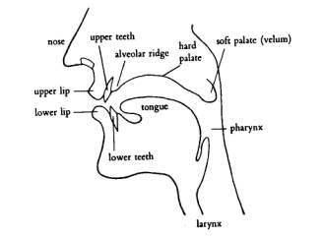
- Plosive = a consonant which is produced by stopping the airflow using the lips, teeth or palate, followed by a sudden release of air (e.g. BAM)
The voiced ones are t, k and p; the unvoiced ones are d, g and b.
- Fricative = a consonant made by the friction of breath in a narrow opening, producing a turbulent air flow
(e.g. f, th)
- Affricative = a speech sound consisting of a stop and a fricative articulated at the same point
(e.g. ‘ch’ in chair, ‘j’ in joy)
- Velar = pronounced with the back of the tongue near the soft palate
(e.g. k, g)
- Voiced/ unvoiced = Some consonants come in pairs, like ‘b’ and ‘p’ are articulated in the same place in the mouth with the same tongue position, but ‘p’ is unvoiced because there is no vibration of the vocal chords, yet ‘b’ is voiced (because vocal chords vibrate). Can be tested by placing your hand on your throat to feel the difference.
- Glottal = sound articulated at the glottis
(better, wetter, letter)

Grammar
- The development of grammar is an unnoticeable process and it happens very quickly. Over three or four years, children master the grammar of the language. When they attend their first school, they give the impression of having assimilated at least 3/4 of all grammar there is to learn.
Stages of Grammatical Growth: David Crystal
- Holophrastic 12-18 months: The earliest stage is hardly like grammar at all, as it consists of utterances of only one word long, for example ‘dada’ or ‘hi’. Approximately 60% of these words have a naming function and 20% express and action. Most children of around 12-18 months go through this stage, known as the holophrastic stage as they put the equivalent of a whole sentence into a single word.
- Two word stage 18 months-2 years: This next stage is more like real grammar from 18 months to 2 years. It is known as the two-word stage as the children put 2 words together to make one sentence structure. For example, ‘cat jump’ which is subject + verb, or ‘shut door’ which is verb + object. By the end of this stage we are left with the impression that children have learned several basic lessons about English word order. There are still lexical items which are missed out, like prepositions (in, on, with). The majority of omissions primarily belong to functional categories including tense marking on verbs-( dropped and sleeping), pronoun, articles, auxiliary verbs ‘to be’ (I am happy, you are silly).
- Three word & four word stages 2-3 years telegraphic: This next stage is filling simple sentence patterns by adding extra elements of clause structure and making the elements more complex. 3 elements for example ‘Daddy got car’ and then 4 elements ‘you go bed now’, show this progress. Or the children start to ask questions like ‘where Daddy put car?’. This takes up much of the third year and is known as the telegraphic stage as simple words like determiners e.g. the, are left out but the sentence is still understood.
- At 3 years, sentences become much longer as the children string clauses together to express more complex thoughts and to tell simple stories. Children at this stage commonly use ‘and’ or other linking words such as ‘because’, ‘so’, ‘then’ etc.
- At 4 years, the children are ‘sorting out’ their grammar. For example most children at the age of 3 ½ might say ‘him gived the cheese to the mouses’. However at 4 ½ years they would say ‘he gave the cheese to the mice’. This explains that they have learnt the forms of the irregular noun ‘mice’ and the verb ‘gave’, and the pronoun ‘he’.
- After 4 ½ years, there are still features of grammar to be used such as sentence-connecting features. This process will continue until early teens when the learning of grammar becomes more indistinguishable.
Active with Passive
- Crystal carried out an experiment testing whether children at certain ages used active or passive sentences. His study shows that at around 3 years old, none of the children produced a passive sentence. However as he tested older children they were beginning to use more passive sentences. At 7 years, the ability to use passives dramatically increased.
Foundation Year
- Crystal believes that language acquisition is not just about producing sounds, but also about being able to perceive sounds and understand the meaning of utterances that people make.
- He says that babies respond to different types of sounds by being able to distinguish between different voices. Before the babies are 1 day old they can tell which is their mother’s voice to someone else’s voice. As well as contrasts in intonation and rhythm.
- The babies also show signs of comprehension between 2 and 4 months. They do this by responding to different adult tones of voice such as angry or soothing.
- Between 6 and 9 months, the child learns to recognise different utterances in situations for example ‘clap hands’ or ‘say bye-bye’.
- Towards the end of the first years, the children show a sign of verbal learning whether it is names of people or objects. Therefore knowing the meaning of at least 20 words by the end of the first year before even uttering a word.
- Overall Crystal’s theory was that children learn in amorphous stages by trial and error to successfully learn the language. They learn in stages of grammar, different types of questioning e.g. intonation and recognising the rhythms of voices.
Jean Aitchison
Jean Aitchison proposed that “language has a biologically organized schedule”.
- Children everywhere follow a similar pattern. In their first few weeks, babies mostly cry.
Crying exercises the lungs and vocal cords. But crying may once have had a further evolutionary purpose. Yelling babies may have reminded parents that their offspring exist: deaf ringdoves forget about their existing brood, and go off and start another.
In 1987, she identified three stages that occur during a child’s acquisition of vocabulary: labelling, packaging and network building.
1. Labelling – The first stage and involves making the link between the sounds of particular words and the objects to which they refer e.g. understanding that “mummy” refers to the child’s mother. In other words, associating a name with something.
2. Packaging – This entails understanding a word’s range of meaning. Understand a word can have a range of meanings- ‘bottle’ has different shapes and sizes, but they are all still a bottle. This is when Over-extension and Under-extension become a hurdle in the development of the language.
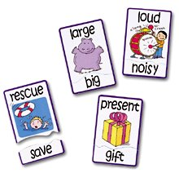
3. Network Building – This involves grasping the connections between words; understanding that some words are opposite in meaning (Synonyms and antonyms). Aitchison argued that there are no EXACT dates to which a child reaches a certain stage of learning language – some children learn faster than others. She believed that the speed of learning is influenced by both innate abilities and environment. Language is partly learned by imitation, so parents and brothers/sisters play a role in the acceleration of learning the language. Baby talk whilst learning to speak could hinder the child in learning to speak later on.
Speech time table created from birth to ten years old.
- According to Aitchison’s Timetable of Speech, children grasp the use of single words at 12 months
M: Mmm! isn’t that nice?
C: More. M: Okay! Here comes the aero plane!
C: Yeh.
- By the age of 2, the understanding of word endings begins to appear. However, it’s a bit complicated at times for the child to always get it right, as some past tense verbs require no ending and it is placed by the child anyway. This is an example of them learning actively.
D: Are you going to tell Mummy what you did today?
C: I roded on a horsie!!
- During the age of 2 is when Aitchison believes negatives are formed and the ability to ask questions is developed:
M: Catch! *throws ball*
C: *misses* Why didn’t I caught it?
M: It’s alright, smile don’t sulk!
C: I not crying.
- At 5 years the child is able to speak using complex constructions and rarely faults:
C: Can I go to Joe’s for tea? We are going to play football in the park like last week.
M: If you stay clean
This is the process of language acquisition. Naturally, children will vary individually when they reach each stage but there is little variation in the sentence of language learning. By the end, a child’s language is in place and will have a basic lexicon of several thousand words. From now on, what is learned is retained and increasingly dependent upon experiences and environment – on opportunities to use language and hear it used, for a wide range of purposes and audiences in a wide range of contexts.

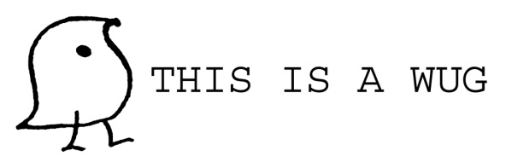
How children build up longer sentences? (WUG test)
Jean Berko Gleason demonstrated how children create plurals. Some children were given a ‘wug’ as a singular, then shown with ‘there are now two of them’. The children had to reply with ‘There are two wugs’. The suffix ‘s’ was added to test the children’s understanding of grammar because it represented the plural which had never been taught to them before with regards to the made up ‘wug’, so testing how they applied their grammar.
- 75% of 4-5 year olds got the suffix correct compared to 97% 5-7 year olds. (supports Chomsky’s LAD)
- They found it harder to add ‘-es’ (houses, glasses), suggesting they struggle to pluralise something that already has an ‘s’ ending because it’s difficult to vocalise.
- It’s also harder for children in complex syllable/phoneme words.
The ‘wug test’ and wider research into how children use endings like ‘-ed’, past tense and comparatives ‘-er/est’, reveal a U shaped development of correct usage.
It starts high, drops off as they start to internalise systematic aspects of the linguistic system. Children must have picked up one example and then generalised it. This enables them to produce plurals, past tenses, possessives and other forms of words that have never been heard before.
The tests are very robust and always produce similar findings. This is the first experimental proof that children have extracted generalisable rules from the world around them.

Example: A four year old is talking about what he wants to be when he grows up:
Adult: What do you want to be when you grow up?
Child: A Dowboy
Adult: So you want to be a dowboy, eh?
Child: (Irritated): No! Not a dowboy, a dowboy!
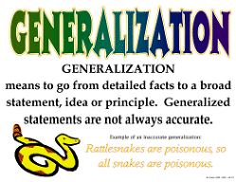
Overgeneralisation: These are over-extensions of grammar (‘virtuous errors’ as opposed to mistakes)
- “I falled off the chair”
The child has never heard anyone say that before, the child clearly understands the general grammatical principle that to express a past tense the ‘/d/’ sound must be added, but it is being applied in this case to a word that is irregular, making it an overgeneralisation.
- It is far from a mistake, because the child is constructing an understanding of English grammar.
- It’s the same for sheep/sheeps, mouses/mice, fish/fishes
Roger Brown found that children understand overgeneralisations to begin with, they then learn the exceptions which take place over the course of 6 months to become accurate
Gary Marcus in 1992 came up with broadly similar points, but noticed how few errors children made (roughly 10% of past tense forms were incorrect).
He proposed a model which suggested that children have a choice when faced with past-tense verbs
They can either add –ed or retrieve a special form
This explains why children say ‘runned’ or ‘seed’ (I saw) and also why they say ‘founded’ and ‘ranned’. They heard a rule system and they need to say exceptions incorrectly and be corrected to understand.
Auxiliary verbs
This next bit will explain how children refuse and articulate something without simply saying ‘no’.
I AM RUNNING
- The ‘running’ is simply the lexical verb
The ‘am’ is the auxiliary verb which gives more info on what is ‘doing’.
The negator ‘not’ must follow the first auxiliary – I am not running
- You must have seen him/ you mustn’t have seen him
- As in questions, if no auxiliary is present in the positive form, then the auxiliary ‘do’ must be added to take the negation, and tense marking passes from the main verb to do:
- Run away/ do not run away
- I ate my dinner/ I did not eat my dinner
Positive form Negative form
- Adult-like negatives with consistent auxiliaries emerge from 2-3 year olds
Although there are still some small errors, especially with ‘do’ where children often mark the past tense on both ‘do’ and the main verb – I didn’t took it
- The comprehension of complex negative structures is acquired late (from 4+) and remains problematic even for some adults.
E.g. Double negatives (I haven’t seen nothing)
Concealed negatives (Tom was hardly pleased)
with embedded propositions (Tom didn’t know Bill was angry)

Bellugi
- Asking questions and saying ‘no’ are two things that we might expect children to do as well.
Children construct these two functions of language: Bellugi suggests 3 stages for forming negatives.
Stage 1 (2 years): children use ‘no’ & ‘not’  Telegraphic talk is rising and you can see the introduction of ‘wh’ words used.  They usually start at the start or end of clauses, and are not grammatically sophisticated | No...wipe finger  No sit there  Where mitten no  No fall!  Not my bed
Stage 2 (2 years, 3 months): They appear mid-utterance and in the form of contractions. The ‘no’ & ‘not’ are in front of verbs.  ‘No’ will become not, because it is in the right position sometimes, just not always shown as ‘not’. | I can’t catch you  You can’t dance  I don’t know his name  That no fish school  He no bite you
Stage 3 (2 years, 9 months): There exists a variety of auxiliaries, though they aren’t quite perfect.  They are mostly correctly positioned and in contraction form | This can’t stick  I didn’t did it  I didn’t caught it  Donna won’t let go  That was not me  I not crying

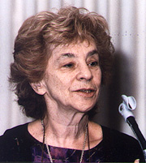
- Bellugi also explored children’s pronoun use and found 3 stages:
1) Use their own name – “Marco play”
2) Recognises I/me pronouns – “I play”, “Me up”
3) Uses pronouns according to whether they are the subject or object position – “I play with the toy”, “Give it to me”.
Bloom on Bellugi (1970)
Bloom disputed Bellugi on on stage 1 – many of the initial ‘no’s may have been misinterpreted and were probably negative comments, followed by an affirmative sentence.
- E.g. No Louis do it actually means No, Louis will do it
- 3 concepts for negative meaning attached to children’s negative sentences in conjunction with the syntax used.
Non existence | To express the absence of something as in ‘No ball’ or ‘Mummy not here’
Rejection | To express refusal as in ‘Me not sleep/ me want carrots’
Denial | (of a preposition) as in ‘I not naughty/no say it’ (meaning I didn’t say it).

Inflections
Studies have suggested that inflections are learnt in a certain order
Brown (1973)
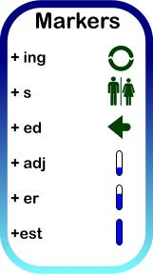
Research has identified a predictable pattern in the acquisition of inflectional affixes (e.g.word endings such as -ed and -ing). Functional words such as determiners ('a', 'the') and auxiliary verbs also seem to be acquired in a regular order.
Brown (1973) studied children's language development between the ages of 20 months and 36 months and found that the sequence shown below occured regularly (features are listed in the order in which they were acquired):
1.) Past participle (-ing) “I going”
2.) Plural (–s) “Shops”
3.) possessive (-'s) “Mummy’s bag”
4.) Articles ('the','a') “Get the bottle, mummy”
5.) past tense (–ed) “I smacked my brother”
6.) third person singular verb ending (-s) “She sings to me”
7.) auxiliary (will, be, do, have, is) “It is snowing outside”

- Another study by Cruttenden (1979) divided the acquisition of inflections into three further stages
Inconsistent stage (first stage) | Children may memorise words on an individual basis and have no regard for general principles on rules. This means they may at first produce the correct plural form of ‘foot’ (feet) because they learnt the word but not the grammatical adaptation
Consistent usage but misapplied at times (second stage) | They show awareness of the general principles governing inflections and as a result may apply regular endings to words that require regular inflections. For example, they observe that plural nouns usually end in –s, so they use ‘foots’. Similarly, they observe that past tense forms usually end in –ed, so instead of ‘ran’ they say ‘runned’. This is an overgeneralisation!
Consistent usage (third stage) | Correct inflections are used, including irregular forms – mouse/mice

Asking questions
Research suggests this happens in 3 stages too
- Relying on intonation in the two word stage. E.g. Daddy home? (rising tone)
- During their second year, children will acquire question words such as ‘what’ and ‘where’ resulting in questions such as ‘where daddy gone?’. They can’t yet use auxiliaries such as ‘where has daddy gone?’
- In their third year, children can use auxiliaries and learn to say, ‘Is Joe here?’, however, they can’t always use wh-words correctly yet and say things like ‘Why Joe isn’t here?
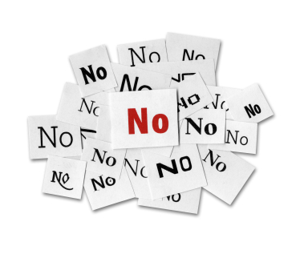
Negatives
This too, happens in 3 stages
- Words ‘no’ and ‘not’ are used in front of other expressions e.g. no want
- During the third year ‘don’t’ and can’t’ are used e.g. I don’t want it
- In the third stage more negative forms are acquired such as ‘didn’t’ and ‘isn’t’ and negative constructions are used more accurately.
Nelson (first words)– Found that 60% of children’s early word phrases contained nouns, then verbs, pre-modifiers and phatic. She said that also nouns were more commonly things that surrounded the children i.e. ‘Ball’, ‘Mum’, ‘cat’. Nelson also said in Re-casts (e.g. child: “Me ball” Mum: “Pass me the ball”), children whose sentences were re-cast performed better at imitating sentences.
Rescorla (overextensions) – suggested there are two types of overextensions:
- Categorical – when a word is used to refer to things in the similar category
e.g. ‘dada’ for mother’, ‘truck’ for bus, ‘apple’ for orange.
Semantically linked.
- Analogical – Words have no clear categorical relation
Divided into:
Perceptual- ‘tick tock’ for the sound of water
Functional – ‘hat’ for basket on head
Affective – ‘hot’ for objects that are forbidden to touch.
- Underextension is the opposite. For example, a child may only call black labs 'dog' but no other dogs. Or calling their rattle a rattle, but calling other ones 'toys'.

Child Directed Speech (CDC)
The question will always be – Referring in detail to the transcript and to relevant ideas from language study, analyse the language used by caregivers and their children. (48 marks)
- Child Directed Speech is the adapted language used specifically to talk to children- “Even four year olds adjust their language when speaking to a two year old”

The functions of Child Directed Speech are to:
- Attract and hold the baby’s attention
- Help the process of breaking down language into understandable chunks
- Make the conversation more predictable by keeping the conversation in the ‘here and now’ and referring to things the baby can see (Piaget’s object permanence).
Does child directed language influence children’s language development?
- Children tend to imitate stressed words
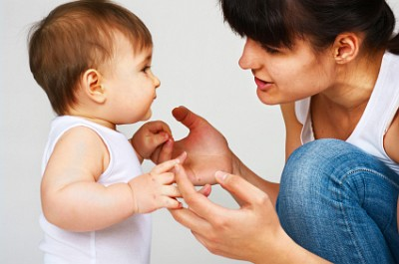
- Exaggerated intonation patterns help children to find these words
- Adults tend to label objects in a more general way, calling tulips, roses and daisies ‘flowers’ because the child is more likely to respond to something they understand
- Parents use questions where the wh-word doesn’t appear in its usual place, but where the baby must replace with a word:
Child: I ate it
Mother: You ate what? (rather than ‘what did you eat?’
Child: the sweet
Some children are not spoken to by their parents in some cultures, and yet they learn their mother tongue all the same. Steven Pinker suggests that the behaviour of Western Middle class mothers is neurotically concerned with their child’s acquisition of language- a parallel to that observed in some African societies where mothers are anxious to teach their children to sit up.
- Overcorrecting of a child (for example the ‘fis phenomenon’) can have a detrimental effect on a baby. This contradicts Skinner & other behaviourist explanations.
- Parents also refer to the children’s name instead of pronouns
- The present tense is common
- One word sentences/short elliptical sentences
- Yes/no questioning
- Fewer verbs and modifiers
- Concrete nouns
- Expansions and/or recasts (rephrasing child’s utterance)
- Exaggerated pauses for giving turn taking cues
The effects of CDS
- Speaking slowly and using simplified vocabulary and grammatical structures makes language more accessible for a child.
The comprehension of a language and the development of the ability to use it is therefore made easier.
- Understanding a word’s meaning is facilitated when an adult focuses the child’s attention on an object in the immediate environment and slowly repeats the name.
- The use of higher pitch and exaggerated intonation (as well as facial expressions and gestures) serve to retain a child’s attention to listen attentively to what is said.
- Asking questions and pausing for a reply also will help to introduce children to the rules of conversation.
Problems with CDS
- It’s argued by some that baby talk (e.g. using expressions such as ‘doggie’ and ‘moo-cow’) interferes with language development because it provides children with inaccurate and distorted speech.
Features of CDS
Phonology
- Slower, clearer pronunciation
- More pauses, especially between phrases and sentences
- Higher pitch
- Exaggerated intonation and stress
Lexis
- Simpler, more restricted vocabulary
- Diminutive forms (e.g. doggie)
- Concrete language, referring to objects in the child’s immediate environment

Grammar
- Simpler constructions
- Frequent use of imperatives
- High degree of repetition
- Frequent questions
- Use of personal names instead of pronouns (e.g. ‘Mummy’ instead of ‘I’)
Pragmatics
- A great deal of gestures and body language
- Fewer utterances per turn (breaking it down into smaller bits, stopping for the child to have their say)
- Supporting language (when a child says something partly unintelligible, adults often echo the utterance replacing the unclear but with a question to encourage them to repeat it).

The other index stuff
Phonemic contraction – Occurs at around 9-10 months when the number of phonemes in a child’s vocabulary contracts to just those found in their native language. Studies have found noises made by babies around this age sound different if they have different nationalities.
Phonemic expansion – Phonemes are the smallest elements of sound. During the ‘babbling’ phase the number of different phonemes a child knows expands
Idiolect – An individual’s own ‘linguistic fingerprint’
Register – A variety of language appropriate to a particular purpose or audience
Phoneme – the smallest sounds in the sound system of a language
Morphology – The formation of words from smaller units, called morphemes. E.g. ‘hyper’ is a morpheme, so adding the suffix ‘active’ to create ‘hyperactive’ is morphology
Language Acquisition Device – Brain’s inbuilt capacity to acquire language and is supported by Chomsky’s nativist standpoint
Lexical & semantic development – The development of a child’s vocabulary and their understanding of those words. These may not always develop at the same rate
The patterns first words tend to follow – Entities (e.g. being, such as ‘mum’, ‘dog’), Properties (e.g. ‘big’, ‘small’), Actions (e.g. ‘Going’, ‘run’), Personal/social (e.g. ‘mine’, ‘you’).
Types of nouns – Concrete nouns (real physical things that can be measured ‘guitar’, ‘table’,) Abstract nouns (Ideas, processes, occasions, times and qualities which can’t be measured ‘love’, ‘happiness, ‘confinement’) Common nouns (classify things into general categories ‘car’, ‘dog’, ‘flowers’).
Count nouns (can be counted, have a plural form but can’t proceed the determiner much ‘One lorry two lorries’, ‘One pen two pens’)
Non count nouns (substances and qualities that can’t be counted, have no plural form and can’t follow the determiner ‘a, though many can be used after quantity verbs such as some, any, all or much ‘information’, ‘hockey’, ‘traffic’.)
Personal pronouns (subject pronouns are the actors of the clause, ‘I, you, he/she/it’, when the pronoun is receiving the action of the verb it becomes an object pronoun ‘me, you, him/her/it’)
Possessive pronouns (show possession ‘mine, yours, his/hers’)
Reflexive pronouns (same person is the actor and receiver in a clause to create emphasis, ‘myself, yourself, himself’)
Demonstrative pronouns (point to the relationship between the speaker and the person with a ‘deictic function’, ‘this, that, these, those’)
Interrogative pronouns (Who, what, whom)
Indefinite pronoun (of pronouns – all of, both of, each of, either of, neither of, some of. Compound pronouns – Every, some, any, no+thing, -one, -body’)
Underextension – when a word is given a narrower meaning (e.g. ‘cat’ is given for the family cat but not other cats)
Overextension – When a word is given a broader meaning that what it actually as (e.g. ‘dog’ for all four legged creatures. This can also apply to suffixes at the end of words for example overextending ‘sheep’ to ‘sheepses’.)
Auxiliary verb – Suggests either possibility or certainty (e.g. should, could, would)
Holophrastic stage – 12-18 months one word sentences (e.g. ‘milk’ rather than ‘that is milk’.) they may also combine two words (e.g. ‘allgone’).
Often used as a naming function. Context, intonation and gesture help the adult understand
Two word stage – 18 months, two word utterances. Grammatically correct but commonly omit elements such as connectives because they carry less information
Telegraphic stage – 3 or 4 word utterances that may be grammatically complete, however determiners, auxiliary verbs and prepositions may be omitted (e.g. ‘Daddy home now’ rather than ‘Daddy is home now’) More questions, commands and simple statements will be used.
Post- telegraphic stage Around 3 years rapid progress is made and determiners start to be used. More than one clause in a sentence. At 5 years many of grammatical functions are learnt, though not mastered
Determiners – a modifying word that determines the kind of reference a noun or noun group has (e.g. a, an, the, some, every)
Inflection – Inflections change the mood, tense and voice. For example, the plural inflection of ‘dog’ is ‘dogs’ to the plural inflection through the –s
Nativist theory – Nativist theory suggests that all humans have an inbuilt capacity to learn language (Noam Chomsky). Supported by Berko Wug. Refuted by studies of feral children’s ‘critical period’ where language needs to be acquired otherwise it’ll never be learnt. Interaction is therefore necessary for language development.
Behaviourist theory – Language is acquired through imitation and reinforcement (Skinner).
Supported by children forming sentences they’ve never heard before. Supported by children hearing incorrect grammar spoken but they still learn correct language. Supported by Fis that they understand correct pronunciation, but may not be able to produce it.
Social interactionist theory – Child language acquisition is developed through interaction with adults (Bruner & Vygotsky). Supported by routine and rituals to help children develop spoken discourse such as turn taking. Supported by Halliday’s research into the functions of speech and suggest the importance of social interaction.
Refuted by children in cultures where CDS is not encouraged – Samoan children still learn to speak.
Cognitive theory – Language acquisition is part of a wider development of understanding that develops as the child experiences the world around them (Piaget).
Refuted by children with cognitive difficulties who still manage to use language beyond their understanding. Refuted by children who acquire language without having an understanding of it, particularly in early stages of development.
Refuted by the ‘fis phenomenon’ which suggests children’s cognitive understanding can be present but their physiological development still impacts their ability to use language.
Expansion (CDS) – The development of a child’s utterance into longer, more meaningful forms
Recast (CDS) – The commenting on, extending and rephrasing of a child’s utterance.

