Examine the causes of the Haiti Earthquake
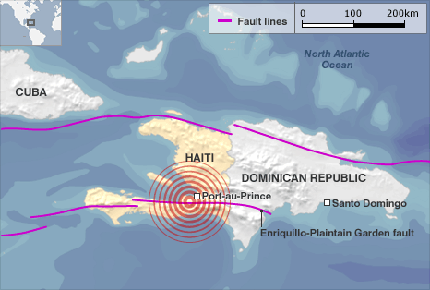
On Tuesday the 12th January 2010 a magnitude 7 earthquake which had a duration of 45 seconds hit the very poor LDC of Haiti. By the 24th January at least 52 after shocks had been recorded, all measuring 4.5 or greater. The epicentre was only 25km away from the densely populated capital city – Port-au-Prince (see map.) Although there are 30-40 magnitude 7 earthquakes a year (USGS) this earthquake soon spiralled into a mega-disaster. This is mainly due to the large vulnerability of the country i.e. cheap building construction, poverty and corruption, and low coping capacity i.e. lack of technology and preparedness. There is a huge toxic cocktail of human factors exacerbating the risk.
Movement along the boundary between the Caribbean and North American plate caused the quake. This is a conservative plate margin where the two plates are moving side by side. It occurred on the Enriquillo-Plantain Garden fault that separates the Gonave micro-plate from the Caribbean plate. The fault was “locked up” for 250 years, tension slowly built up and a sudden strike-slip failure caused the quake.
It was a very shallow focus quake –only 13km below the earth’s surface and therefore there was very severe ground shaking. The released energy was concentrated when it reached Port-au-Prince. The transform nature of the fault explains why the earthquake foci was so shallow unlike quakes at destructive plate margins, which often occur deep below the surface. The huge intensity was also caused by the predominant composition of recent sedimentary rocks that are more prone to shaking than older, harder, more consolidated rocks.
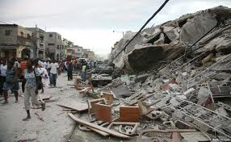
Examine the impacts of the Haiti Earthquake
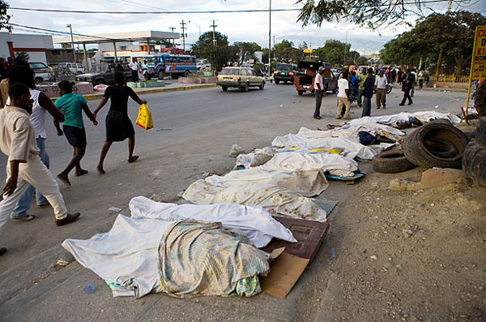
There are many environmental, social and economic impacts caused by the 2010 quake, many of which are still affecting Haitians today, 3 years after the event. The quakes epicentre was only 25km away from the densely populated ‘shanty town’ city of Port-au-Prince and out of the 3.5 million people affected by the disaster, 2.8million of them lived in the capital. The government estimates that 222,570 people died and 300,572 were injured. The majority of the deaths were caused by the pan-caking of buildings – the sprawling shanty towns were built on marginal land and due to little building regulations they were very poorly built, meaning they could not withstand the quake, falling on everyone that was inside a building. 2.3 million people were driven out of their homes and over 180,000 homes were damaged or destroyed, with 1.5 million people left homeless.
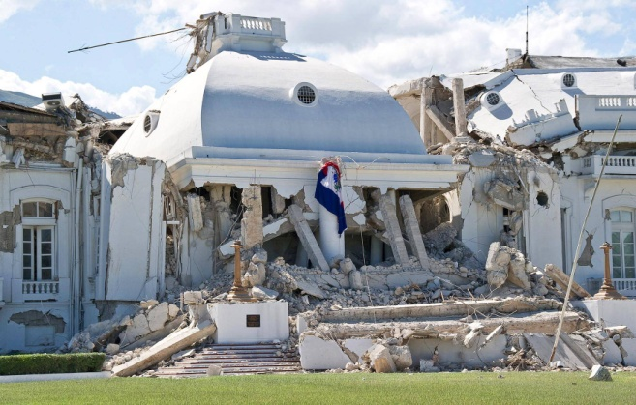
Many notable buildings were significantly damaged or destroyed including the presidential palace, the national assembly building, the Port-au-Prince Cathedral and an important United Nations building. There were 19 million cubic metres of rubble and debris in Port-au-Prince – enough to fill a line of shipping containers stretching end to end from London to Beirut. 1.5 million people ended up living in camps, including over 100,000 at a critical risk from storms and flooding and to worsen problems, there has been a major cholera outbreak since October 2010, with the effects worsened by poor sanitation and limited access to clean water. Over 3,000 have died by December 2010, at a rate of 50 deaths per day.
Nearly 4000 schools were also damaged or destroyed and nearly a quarter of all civil servants on the island died. In addition, the problems were exacerbated by the deaths of many people in the government, the emergency services and the aid organisations, which further disrupted the efforts at rescue and reconstruction. The islands main prisons were damaged, leading to the escape of many criminals and a consequent increase of lawlessness. In conclusion, Haiti’s fragile infrastructure was shattered by the quake.
There were also many lasting economic impacts caused by the quake for the already extremely poor LDC – two thirds of the population had already lived on less than $2 a day (absolute poverty) before the quake. More than half of Haiti’s population – between 5 and 6 million people- live in rural areas and about 85% of this rural population are involved in agriculture which accounts for 26% of Haiti’s economic output and makes agriculture the country’s biggest employer. The destruction of roads, bridges, fishing ports and irrigation infrastructure had a serious effect on food production and therefore the agriculture industry in Haiti.
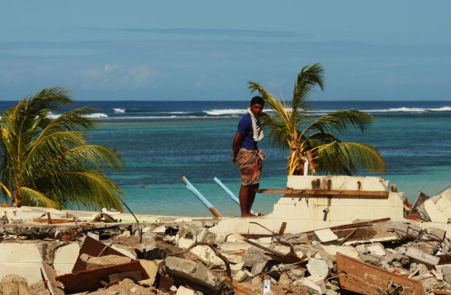
Although the manufacturing industry in Haiti was limited, it was the 17th largest supplier of clothing products sold in the USA, with exports valued at US $412 million. The disaster was a severe setback to the manufacturing industry, with many facilities being damaged and workers lost or injured in the quake. There was also a loss of tourism after the quake and before the disaster tourism was only starting to grow – new hotels were being built, cruise ships started to visit Haiti, and a number of international airlines had services to the country. All of this was disrupted by the earthquake – further setting back the Haitian economy.
The physical consequences include a large amount of lateral and vertical offset caused by severe ground shaking along the fault lines. The general pattern was a bulging up to the North of the faults and subsidence to the South. This meant that most of the southern coast of Haiti retreated back 100 metres. Alternatively, some coral reefs bulged up, breaking the tropical ocean surface, and hence, destroying the corals. Another physical effect of the quake was liquefaction which is a process through which water-saturated sediment loses its cohesion during violent earthquake shaking, causing the sediment to collapse and lose bearing strength. This caused a lot of infrastructural damage.
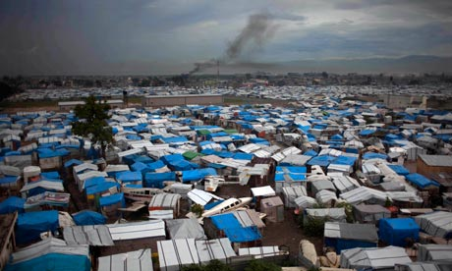
Haiti is still feeling the effects of the quake today – 87% of people made homeless from the quake are still in refugee camps. There are 520,000 people who are still homeless. And more than 70 percent of the workforce is still unemployed. Most Haitians do not have running water, a toilet or access to a doctor. Cholera has claimed thousands of lives and remains a major threat to public health. Haiti remains the poorest country in the Western Hemisphere. Genant Blot, one of the camp’s Secretary Generals, says that “They have shelter and food. But they are right; there are still problems that can be improved. And out here, away from the city, the people just exist. It’s a voluntary prison.”
Assess the success of the response to the earthquake by the various players involved
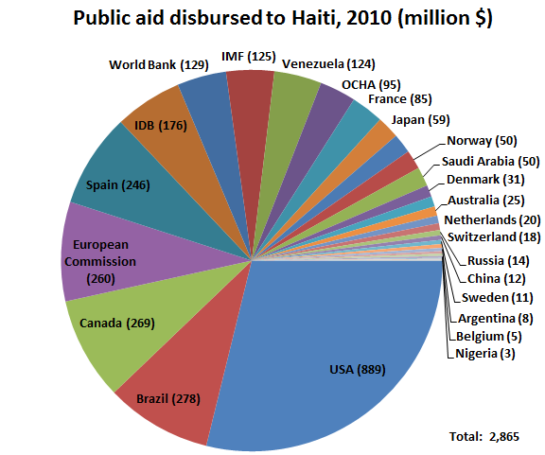
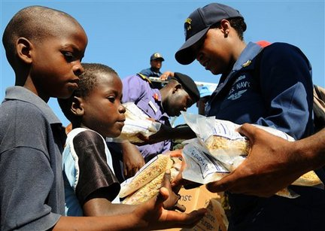
Haiti is a very poor LDC – it has a HDI of 0.47 and its GDP is just $550 per capita, it also has a corrupt government and periodic violence. Therefore, it is not a surprise that relief efforts for the disaster were hugely dependent on foreign aid. Thankfully, there was quite a large response internationally, from players such as governments e.g. the USA, NGOs e.g. action aid and even iconic individuals such as Brad Pitt. Water, food, tents, medicine and rescue equipment soon began to arrive at the airport in Port-au-Prince. Emergency teams were also flown in equipped to help the estimated 3 million people thought to be injured and homeless for example the US government sent over 17 ships, 48 helicopters, 12 fixed-wing aircraft and 10,000 marines. However, the logistics of distributing aid was a nightmare, and problems were compounded by damaged roads and broken lines. The USA were one of the main sources of contributing to the immediate response (see pie chart), the USA have had a history of involvement in Haiti both politically and through aid efforts. The secretary of state Hillary Clinton pledged further long-term assistance to rebuild the shattered country. In late January the UK disasters and emergency committee said that Britons had donated £23 million to the Haiti earthquake appeal. The UK government trebled its funding for the humanitarian response from £6.2 million to £20 million, to provide food, shelter, health and relief work.
One of the immediate needs was to help those that were injured however this was extremely difficult as the main hospital in Port-au-Prince was destroyed, not only destroying facilities but also killing many of the doctors in the capital. Six international and eight Haitian medical teams addressed health needs of the earthquake survivors through mobile medical clinics.
The role of NGOs was extremely important, for example the Red Cross and other agencies supplied a convoy of trucks carrying aid which included a 50-bed field hospital, surgical teams and an emergency telecommunications unit. The Haitians were extremely dependent on NGOs especially because the Haitian government seemed to show a little response immediately after the quake. By the 16th January, however, 250 tonnes of relief supplies passed through the airport, and there had been 110 successful rescues of people buried in the rubble.
The authorities in Haiti did what they could to support the aid efforts but there was little that could be done to help those struggling to survive – the police did arrest over 50 people in an attempt to maintain order. There were also fears that air drops would only encourage riots.
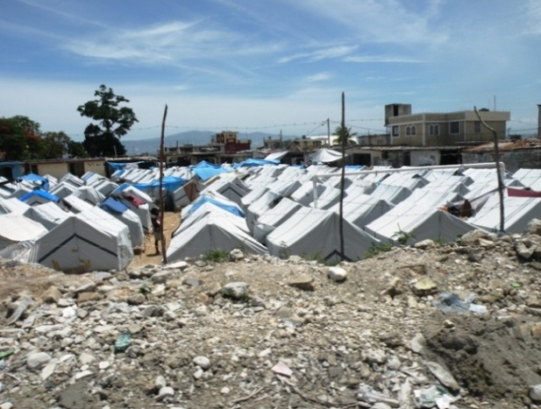
Long term response have been extremely slow, 87% of people made homeless are still in refugee camps. The pace of reconstruction has been slowed by land disputes, inertia, lack of accountability and minimal planning. The corrupt government have used the little money they have to build government buildings rather than housing for its population. Conflicting ideas between governments and NGOs about how to rebuild the city have also slowed down the decision making process. However, many NGOs are still today helping the inhabitants of Port-au-Prince, in 2012 (2 years after the quake) the UN stated that it continues to provide and coordinate wide-scale humanitarian assistance in response to the 12 January 2010 earthquake and cholera epidemic. Donors have pledged $10 billion at the UN donors’ conference to make a difference in the lives of suffering Haitians and almost 90 per cent of the $4.6 billion pledged for 2010 and 2011 is coming through for those who need it. However, if Haiti is to ever truly recover from this disaster, then an effective reconstruction plan for the entire city will have to be produce, and due to the corrupt nature of the Haitian government, this looks very unlikely to happen in the near future.
In conclusion, although there was a huge contribution from international government and NGOs providing disaster relief, the immediate response could have been a lot better which could have saved many more lives. However, due to the huge amount of poverty and the low social class of the inhabitants in Port-au-Prince, not a lot could have been done to reduce vulnerability to such a disaster. Haiti simply doesn’t have the high coping capacity e.g. life safe ‘aseismic’ buildings and preparedness e.g. education towards how to cope with such a disaster. You could argue that the huge death toll created from this disaster was inevitable.

